Direct Instruction Lesson Plan

Author: Sierra Staggs

Date Created: 4/22/14

Subject(s): Geometry

Topic or Unit of Study (Title): Triangle Congruence by SSS and SAS

Grade Level: 10th Grade

Materials: Notes, Homework, Wooden sticks (if necessary), Markers (if necessary)

Summary (and Rationale): To prove triangles are congruent using definition, you must prove that three pairs of sides are congruent and three pairs of angles are congruent. However, there are postulates and theorems that shorten this process. The SSS and SAS Postulates allow you to prove two triangles are congruent by showing only three conditions are true. Congruent triangles are used frequently in examining characteristics of quadrilaterals.

I. Focus and Review (Establish Prior Knowledge): [5 minutes] Review definition of congruent polygons, definition of a midpoint, and how congruent angles/sides are marked.

II. Statement of Instructional Objective(s) and Assessments:

Objectives | Assessments
Students learn how included angles are used to identify triangle congruence using the Side-Angle-Side (SAS)Triangle Congruence Postulate as well as the Side-Side-Side (SSS) Triangle Congruence Postulate.  All students will prove triangles are congruent using SSS and SAS. | Questioning to get students to share with me their thinking so I might clear up misconceptions.  Verbal check - randomly calling on students to assess their understanding of the material through questioning for the purpose of pulling out students’ thinking  Ticket-out-the-door (TOTD)

State the objective: [5 minutes] to draw conclusions about triangles based on congruence postulates.
Assessment: [10 minutes total]

III. Teacher Input (Present tasks, information and guidance): [40 minutes] Introduce the fact that congruent triangles can be proving using (1) three pairs of corresponding sides and (2) two pairs of corresponding sides and one pair of corresponding angles. Define the Side-Side-Side (SSS) Postulate and follow with examples. Present new vocabulary such as included sides and angles. Define the Side-Angle-Side (SAS) Postulate and follow with examples. Compare and contrast.

IV. Guided Practice (Elicit performance): [20 minutes] Work through problems and proofs with class as a whole, only assisting when necessary.

V. Closure (Plan for maintenance): [10 minutes] Pass out homework and allow for students to work on it for the remainder of the class period. This also allows students the opportunity to ask questions before leaving. Must complete at least 3 problems in order to pack up and leave (TOTD).

VI. Independent Practice: [N/A] Whichever questions the students don’t finish at the end of the period will be left as homework.

STANDARDS:
CCSS.MATH.CONTENT.HSG.CO.B.8
HS.TT.1.3

Plans for Individual Differences: Divide students into small groups. Hand out pre-measured wooden sticks of three different lengths. Students can use markers or pencils to color the sticks so each size is a different color. Ask students to form two triangles using one of each color for each side. Ask students if their triangles are congruent. Discuss reasons amongst group mates.

References (APA style):
Charles, R., Hall, B., Kennedy, D., Bass, L., Johnson, A., Haenisch, S., Murphy, S., Wiggins, G. (2011). Geometry. (Teacher’s Ed.). Upper Saddle River: Pearson.

Direct Instruction Lecture Notes
(Presented as PP)
Objectives:
- State postulates of congruence of triangles correctly.
- Apply postulates of congruence of triangles correctly.
- Distinguish between SSS and SAS.
- Correctly interpret and utilize included sides and included angles.
Side-Side-Side (SSS) Postulate:
If three sides of one triangle are congruent to three sides of another triangle, then the triangles are congruent.
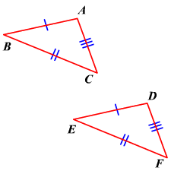
If AB ≅ DE, BC ≅ EF, AC ≅ DF
Then ΔABC ≅ ΔDEF
Included Sides and Angles:
In a triangle, we say a side is included if it is between two referenced angles.
In a triangle, we say an angle is included if it is between two referenced sides.
Example:
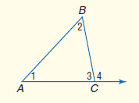
• Side AC is included between angles 1 and 3.
• Angle 2 is included between sides AB and BC.

Side-Angle-Side (SAS) Postulate:
If two sides and the included angle of one triangle are congruent to two sides and the included angle of another triangle, then the triangles are congruent.
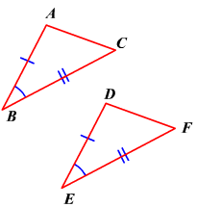
If AB ≅ DE, ∠B ≅ ∠E, BC ≅ EF
Then ΔABC ≅ ΔDEF

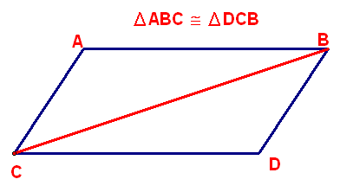

Proof Examples:
Given: AB ≅ CD and BD ≅ AC
Prove: ΔABC ≅ ΔBDC

- AB ≅ CD and BD ≅ AC | 1. Given
- BC ≅ BC | 2. Reflexive Property
- ΔABC ≅ ΔBDC | 3. SSS

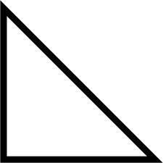
R
S
T
U
V

Given: V is the midpoint of RU and the midpoint of ST
Prove: Prove: ΔRSV ≅ ΔUTV

- V is the midpoint of ST | - Given
- SV ≅ VT | 2. Definition of Midpoint
- V is the midpoint of RU | 3. Given
- RV ≅ UV | 4. Definition of Midpoint
- ∠RVS ≅ ∠UVT | 5. Vertical Angles Theorem
- ΔRSV ≅ ΔUTV | 6. SAS

Class Examples:
Decide whether you can deduce by SSS or SAS that another triangle is congruent to ΔABC. If so, write the congruence and name the pattern used. If not, write no congruence.

- Answer: SSS

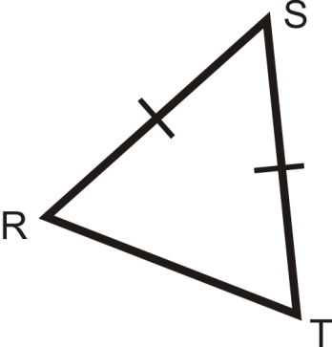
- Answer: No Congruence

A
B
C
P
Q

- Answer: SAS

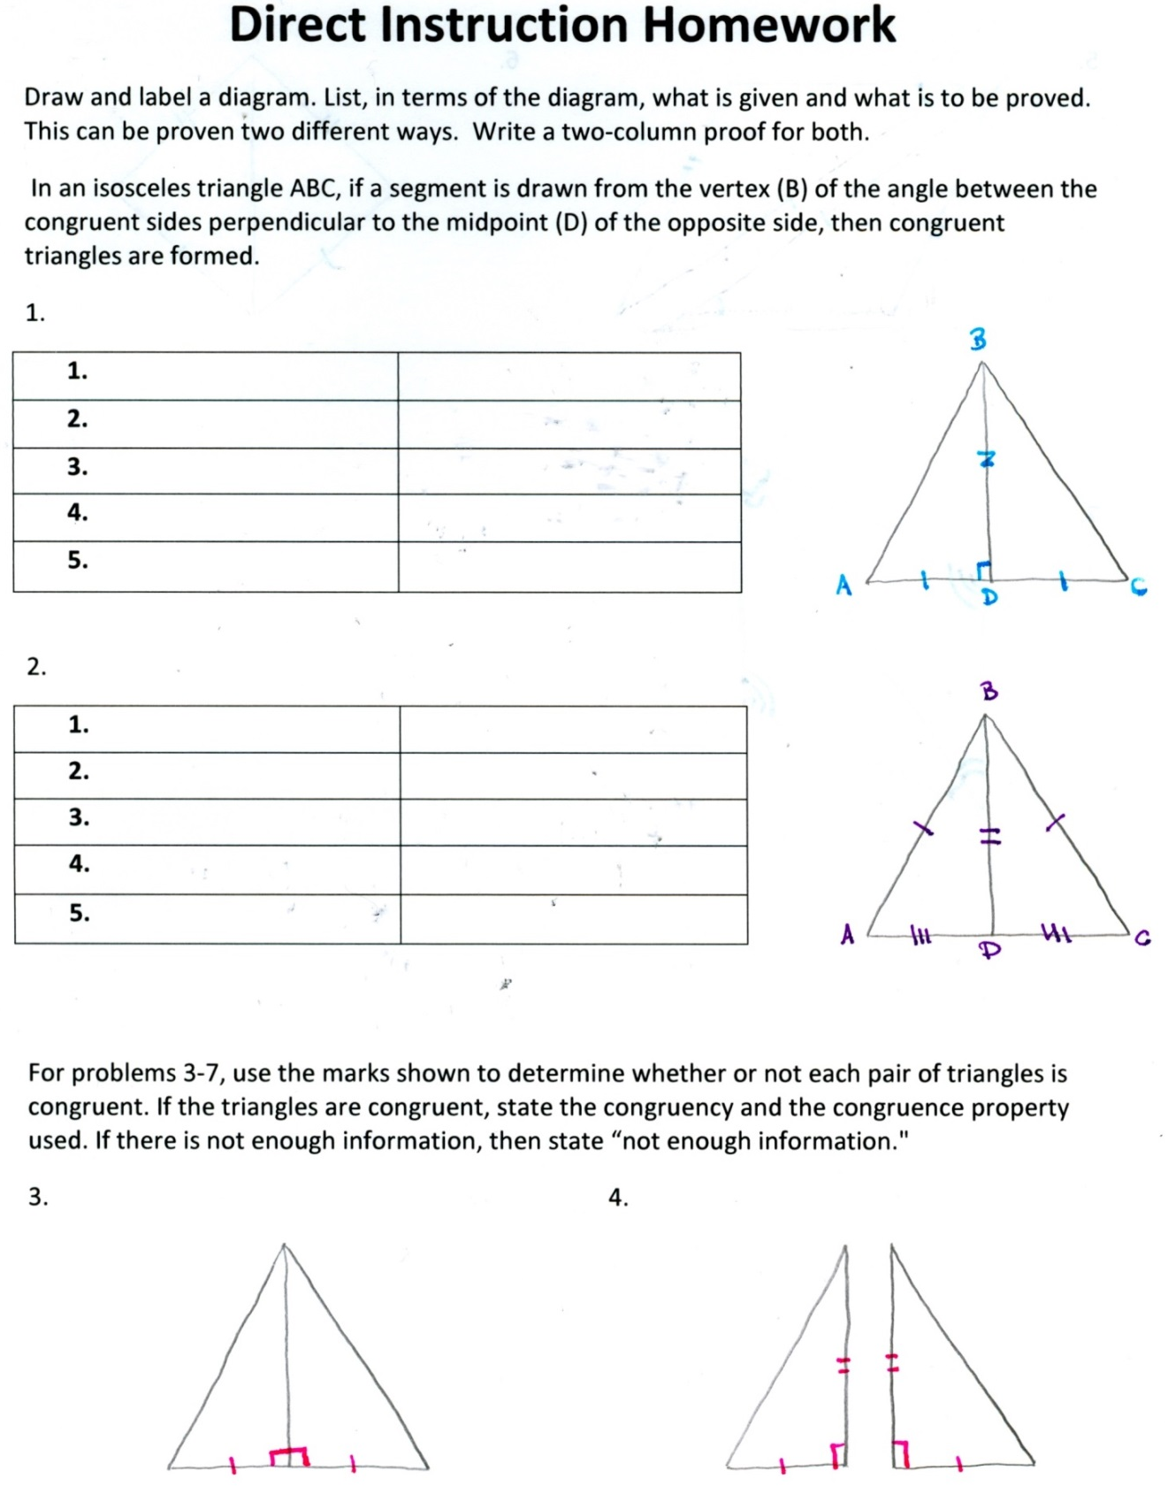

Direct Instruction Homework Solutions
Draw and label a diagram. List, in terms of the diagram, what is given and what is to be proved. This can be proven two different ways. Write a two-column proof for both.
In an isosceles triangle ABC, if a segment is drawn from the vertex (B) of the angle between the congruent sides perpendicular to the midpoint (D) of the opposite side, then congruent triangles are formed.
1.
- BD ≅ BD | Reflexive Property
- ∠ADB ≅ ∠CDB = 90° | Definition of Perpendicular
- D is the midpoint of AC | Given
- AD ≅ DC | Definition of Midpoint
- ΔABD ≅ ΔCBD | SAS

2.
- AB ≅ BC | Definition of Isosceles Triangle
- BD ≅ BD | Reflexive Property
- D is the midpoint of AC | Given
- AD ≅ DC | Definition of Midpoint
- ΔABD ≅ ΔCBD | SSS

For problems 3-7, use the marks shown to determine whether or not each pair of triangles is congruent. If the triangles are congruent, state the congruency and the congruence property used. If there is not enough information, then state “not enough information."
3. SAS 4. SAS

5. Not Enough Info 6. SSS

7. Not Enough Info

