Integrative Lesson Plan

Author: Sierra Staggs

Date Created: 4/24/14

Subject(s): Geometry

Topic or Unit of Study (Title): Using Corresponding Parts of Congruent Triangles

Grade Level: 10th Grade

Materials: Notes, Homework, Graphic Organizers (if necessary)

Summary (and Rationale): Using the integrative model, the goal(s) for the students is to be able to identify corresponding congruencies, use properties and definitions to make claims about given polygons, prove congruencies using theorems/postulates, and then make inferences about other corresponding parts with the introduced concept of CPCTC.

I. Focus and Review (Establish Prior Knowledge): [5 minutes] Review postulates learned so far: SSS, SAS, ASA, and AAS.

II. Statement of Instructional Objective(s) and Assessments:

Objectives | Assessments
After identifying, comparing, and generalizing new concepts, students will be able to synthesize information and create broad statements to represent the deep understandings they have developed. | Instructor will have students summarize the conversations that occurred in class, making notable relationships about information.  (Use this as the day’s TOTD -Ticket-Out-The-Door)

State the objective: [5 minutes] to use triangle congruence and corresponding parts of congruent triangles to prove that parts of two triangles are congruent.
Assessment: [20 minutes]

III. Teacher Input (Present tasks, information and guidance): [15 minutes] Review previously learned postulates to prove triangles are congruent. Introduce CPCTC – Corresponding Parts of Congruent Triangles are Congruent. Describe, compare, and search for patterns in congruencies. Explain the identified similarities and differences. Hypothesize what would happen under different conditions. Make broad generalizations about the concepts learned and discuss.

IV. Guided Practice (Elicit performance): [30 minutes] Practice proving congruent sides and angles using CPCTC.
V. Closure (Plan for maintenance): [15 minutes] Review concepts learned during class. Collect student summaries as their TOTD. Pass out homework when summaries are received.

VI. Independent Practice: [N/A] Complete puzzle for homework assignment.

STANDARDS:
CCSS.MATH.CONTENT.HSG.CO.C.9

Plans for Individual Differences: Have students draw a concept wheel. A middle circle is labeled: Congruent triangle postulates/theorems. Add five spokes off the wheel that lead to five more circles. The five circles are labeled with the concepts in this chapter: SSS, SAS, ASA, AAS, and HL. After each lesson, have students write the postulate or theorem in its respective circle along with an example.

References (APA style):
Charles, R., Hall, B., Kennedy, D., Bass, L., Johnson, A., Haenisch, S., Murphy, S., Wiggins, G. (2011). Geometry. (Teacher’s Ed.). Upper Saddle River: Pearson.

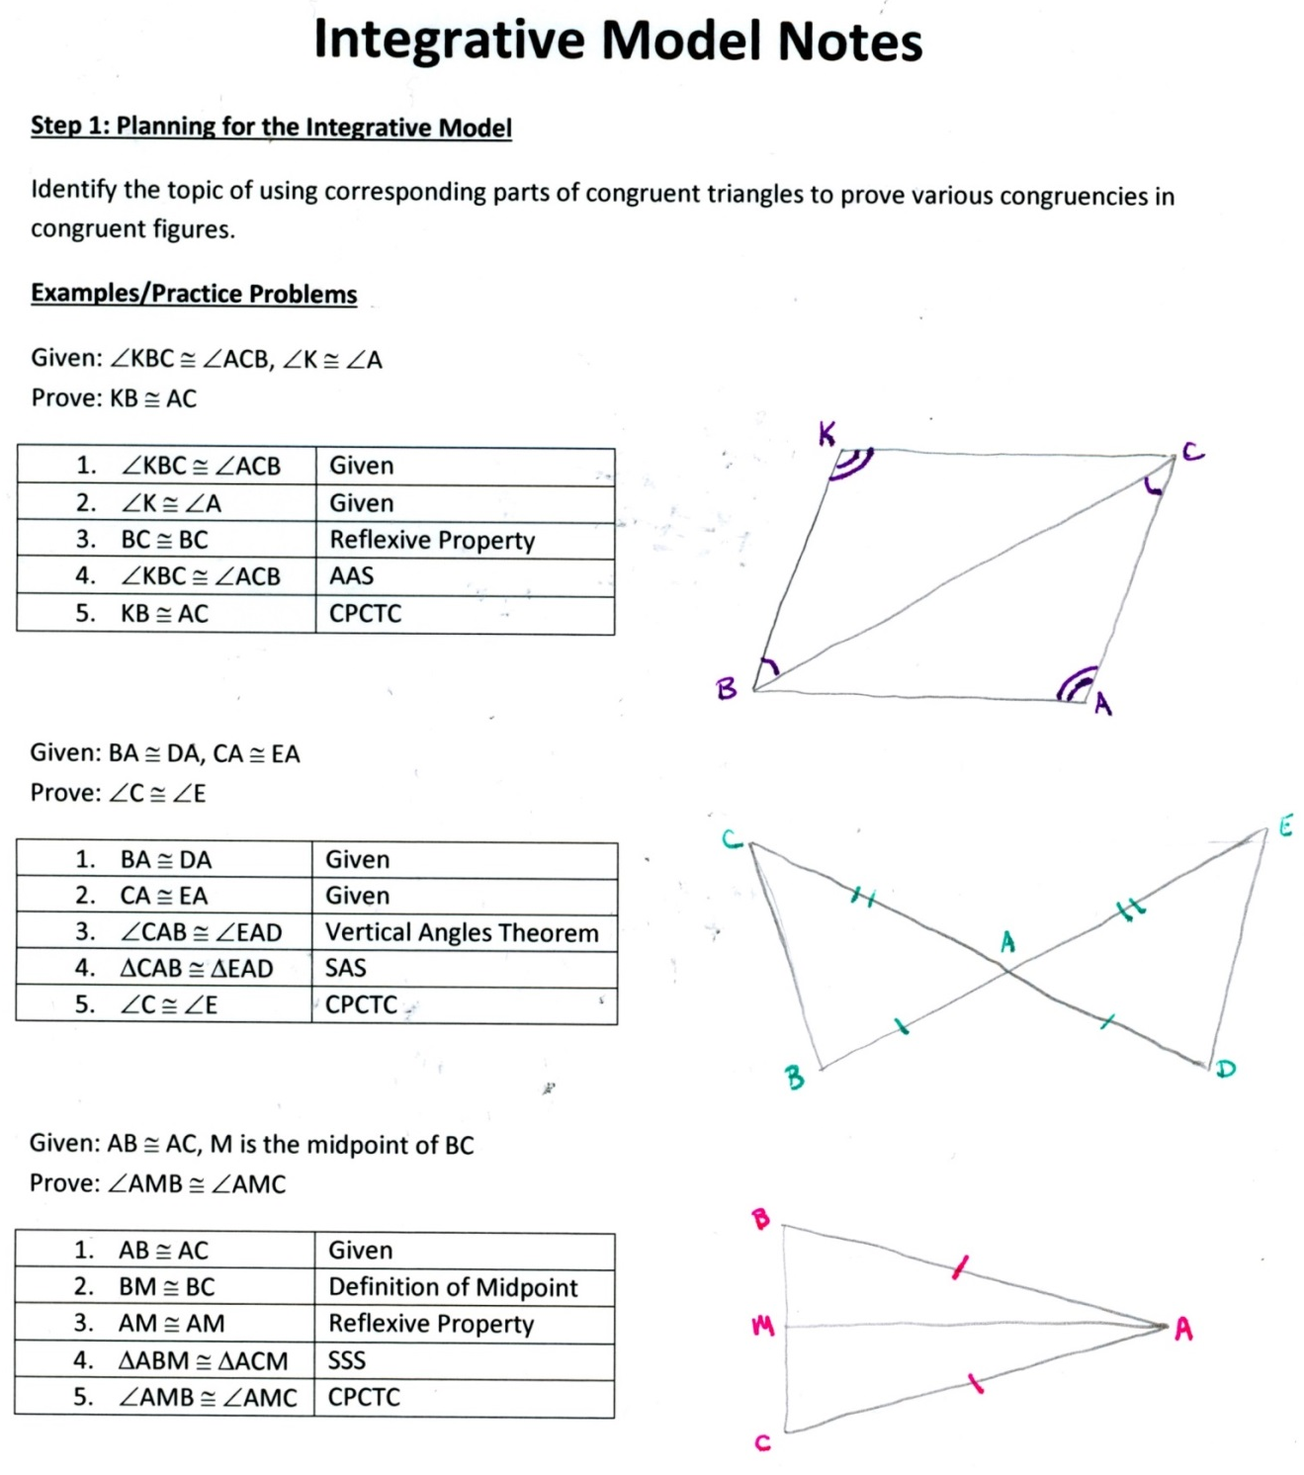

Step 2: Describe, Compare, and Search for Patterns
Describe: What are some definitions used when making claims on congruent polygons?
(midpoint, right angles, bisecting, etc...)
Describe: What are some properties used when making claims on congruent polygons?
(reflexive, substitution, given properties, etc...)
Compare: What are some similar properties/ definitions used in each of the theorems and postulates used to prove congruencies?
(SSS and SAS both need adjacent congruent sides to use as a reason for congruency and, similarly, ASA and AAS both need adjacent congruent angles to use as a reason for congruency, etc...)
Search for patterns: What are some similar congruencies that can be made once two polygons are considered congruent?
(All combination of sides and angles)
Step 3: Explain the Identified Similarities and Differences
Compare similarities between certain definitions and properties.
(midpoint and bisecting both denote two segments being congruent, etc…)
Identify similarities in the proofs of each theorem.
(ASA and AAS are both proven using the Third Angles Theorem)
Step 4: Hypothesize What Would Happen Under Different Conditions
Suppose certain theorems and definitions hadn’t been established yet. What are some other theorems that would be affected by their nonexistence?
(ASA and AAS wouldn’t be able to be proved without the Third Angles Theorem, SSS wouldn’t be able to be used in certain proofs without the use of the Reflexive Property, CPCTC would be useless if we didn’t know the definition of “congruent”, etc...)
Step 5: Make Broad Generalizations about the Topic and the Discussion
Target generalizations: geometry is based off building blocks – everything is connected to each-other, each new concept is essential to building future concepts, no bit of information is “useless”, etc…

