Concept Development Lesson Plan

Author: Sierra Staggs

Date Created: 4/25/14

Subject(s): Geometry

Topic or Unit of Study (Title): Chapter Review

Grade Level: 10th Grade

Materials: Notes, Chapter Review (and Solutions), Laptop synced to a Projector, Internet

Summary (and Rationale): Connecting big ideas and generate original ideas. Practice in brainstorming helps students become more creative and willing to share.

I. Focus and Review (Establish Prior Knowledge): [N/A] No review necessary. The main focus is to have students review material learned in chapter by establishing connections and generate creative thinking.

II. Statement of Instructional Objective(s) and Assessments:

Objectives | Assessments
Students will demonstrate their skills to make connections and generalizations by relating concept ideas to one another. | Have students submit a written general summary about the subject information and why they specifically grouped and named their listed items.

State the objective: [5 minutes] to establish connections and relationships amongst concepts learned throughout the chapter.
Assessment: [10 minutes]

III. Teacher Input (Present tasks, information and guidance): [40 minutes] Have each student place an item on the smart board that are associated with congruent triangles based on general knowledge and material learned throughout the chapter; list as many items as possible. Have the students group the items based on similarities. Name the groups based on reasoning for grouping and relationships between the items. Regroup individual items into new groups with different similarities. Synthesize information by summarizing the data and have students formalize generalizations.

IV. Guided Practice (Elicit performance): [35 minutes] After all information pertaining to the chapter has been recollected and organized, work on review problems for the remainder of the period, leaving time to complete the assessment at the end of class.

V. Closure (Plan for maintenance): [N/A] The assessment/summary will be the closing assignment at the end of class.

VI. Independent Practice: [N/A] Have students study practice problems as review for upcoming quiz/test.

STANDARDS:
CCSS.MATH.CONTENT.HSG.CO.B.8
CCSS.MATH.CONTENT.HSG.CO.C.9
CCSS.MATH.CONTENT.HSG.CO.C.10
CCSS.MATH.CONTENT.HSG.CO.D.12
CCSS.MATH.CONTENT.HSG.CO.D.13
HS.TT.1.2

Plans for Individual Differences: Set students in groups of various achievement levels to work with each-other on the chapter review. Assign groups a particular aspect to spend a set amount of time teaching each-other before moving on to the next topic. For the summaries, have students with less understanding simply write a brief generalization of what they’ve learned throughout the course.

References (APA style):
Charles, R., Hall, B., Kennedy, D., Bass, L., Johnson, A., Haenisch, S., Murphy, S., Wiggins, G. (2011). Geometry. (Teacher’s Ed.). Upper Saddle River: Pearson.

Concept Development Notes
Step 1: Make a List
Have each student approach the smart board and name off at least one item associated with congruent triangles.
Keep items as specific as possible.
For example, if a student says “theorems,” ask him/her to name a specific theorem they can remember.
There should be enough items for each student to have listed one.
After each student has listed an item, allow students to volunteer additional items, if any.
Step 2: Group Items Based on Similarities
After a list of items has been made, have students group the items based on similarities.
Similarity examples are items that deal with angles, items that deal with sides, items that deal with measurements, etc….
Drag and drop items on the smart board so that they are collected together based on students’ suggestions.
Step 3: Name the Groups
With each of the items grouped together, have the students name the groups based on reasoning for the grouping and relationships between the items.
Notice both popular and unique name suggestions.
Work with what is provided.
My Grouped List:
Theorems: Triangle Angle-Sum Theorem, Third Angles Theorem, Vertical Angles Theorem, SSS, SAS, ASA, AAS, Isosceles Triangle Theorem, Converse of the Isosceles Triangle Theorem, Perp. Bisector Theorem (4.5), Corollary to ITT, Corollary to CITT, HL Theorem, CPCTC
Definitions/Terms: Congruent figures, corresponding parts, proofs, bisector, perpendicular, perpendicular bisector, midpoint, equilateral, equiangular
Parts of a triangle: sides/legs, base, vertex angle, base angles, included sides, included angles, angle measures, side lengths, hypotenuse
Properties: Reflexive, Substitution, Transitive, properties of parallel lines (alt. int. angles)
Step 4: Separate and Regroup
Try to have students separate the items listed and regroup them based on different similarities than used originally.
Again, have them name the groups using the smartboard.

Step 5: Synthesize and Summarize
Students will formalize generalizations and submit a brief, written summary/statement about the subject and its content.

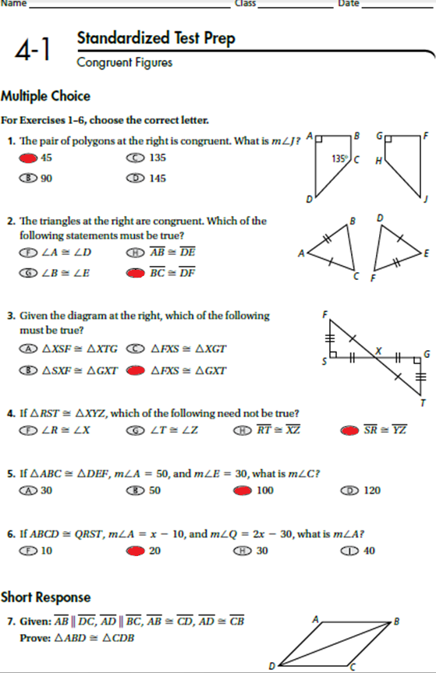

AB ≅ CD and AD ≅ CB | Given
BD ≅ BD | Reflexive Property
ΔABD ≅ ΔCDB | SSS

